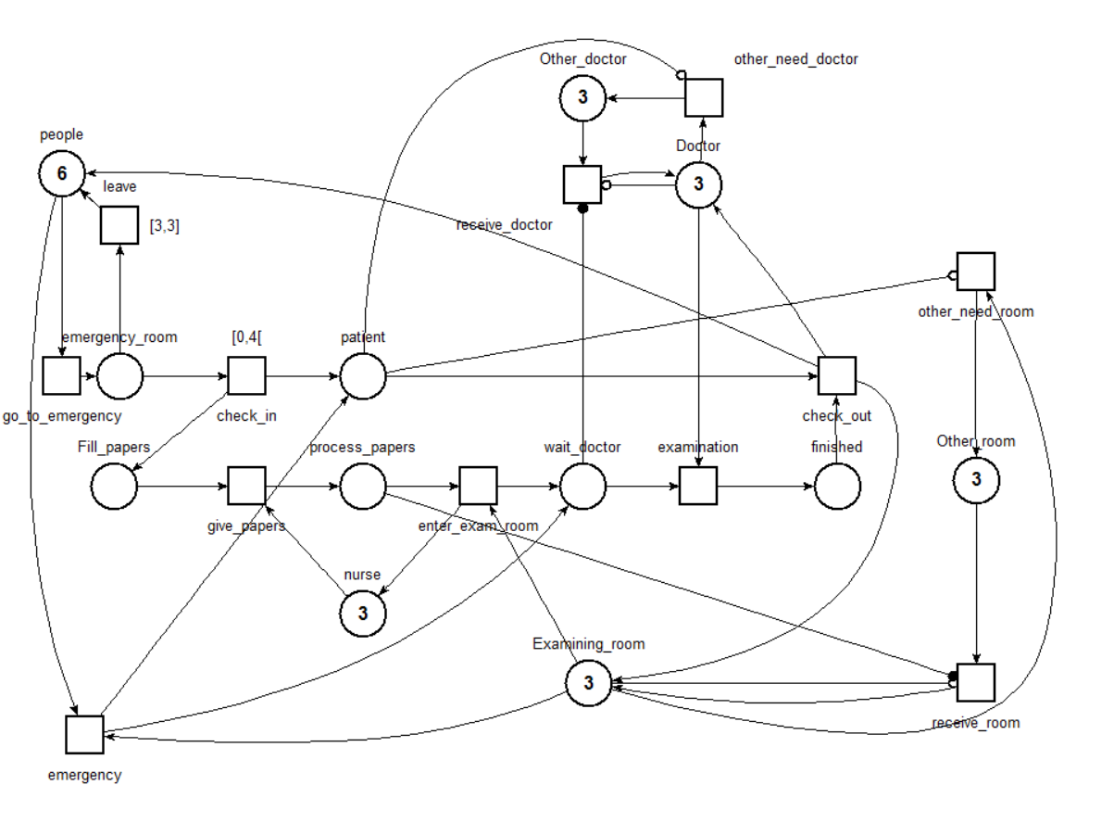

-Deadlock freeness



A patient is in the hospital, people is outside

-When a patient is admitted in the service, he/she will eventually be examined by a doctor



Fill_papers is just after the check in, finished is when the doctor has just examined us.

-Each time an examining room is reserved, it will eventually be released

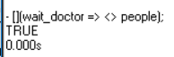

Wait_doctor is when we are in the room waiting doctor, and people is outside the hospital